ㅎ

Brit Stevens 9/19/23

***logo***

Paloalto Firewall SOHO Config/Updates lab

**Purpose:**

The purpose of this lab was to understand the fundamentals of what a firewall is and how to use it in a home office environment. This is just one use of the firewall and was easy to understand as an introduction to its GUI. The other purpose of this lab allow internet access to the firewall so we could download new versions of the software and licenses to keep our firewall up to dates and fully functional. We also allowed internet access through the firewall to the pc’s which allows is to configure what is allowed or disallowed for the pc’s to access in the future.

**Background:**

The PA-220 firewall is a device that allows for secure connection between your home office, could be big businesses too, and the ISP (internet service providers like Comcast or Verizon). On the firewall you can configure vpn’s (a network tunnel that essentially encrypts your data and keeps it private until it reaches its target end destination), set up dhcp distribution (automatically giving Ip addresses to pc’s based on a configured list), and, but not limited to, configuring the interfaces on the firewall to each have their own purpose.

**Problems:**

For this we didn’t have many issues with configurations because we followed a guide from PaloAlto on how to configure the soho network. The few issues we had were mainly just physical issues like missing a power cable or having the cables in the wrong ports which we solved quickly. Another problem we had was just learning the GUI of the PA-220 as it had been a completely new GUI to us, causing us to take some time to learn where we could find each toggle.

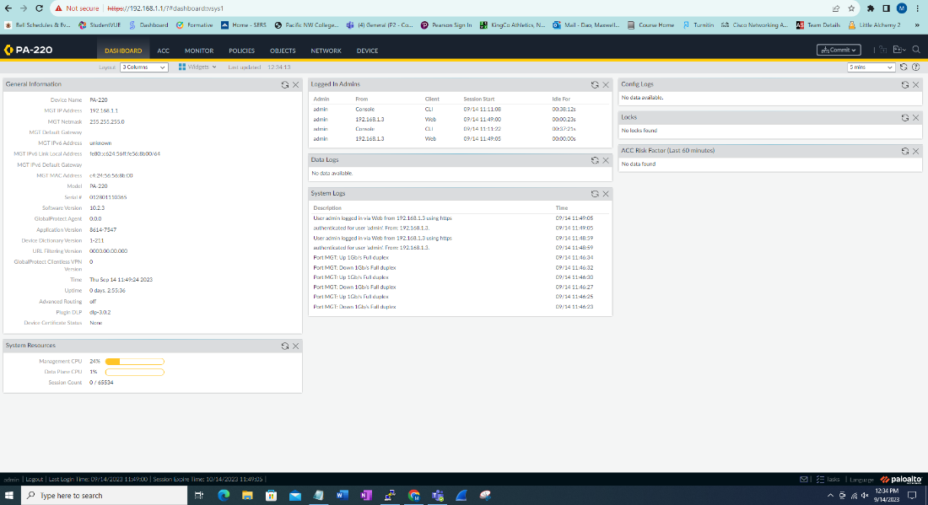

Access the GUI by typing in the IP the firewall.

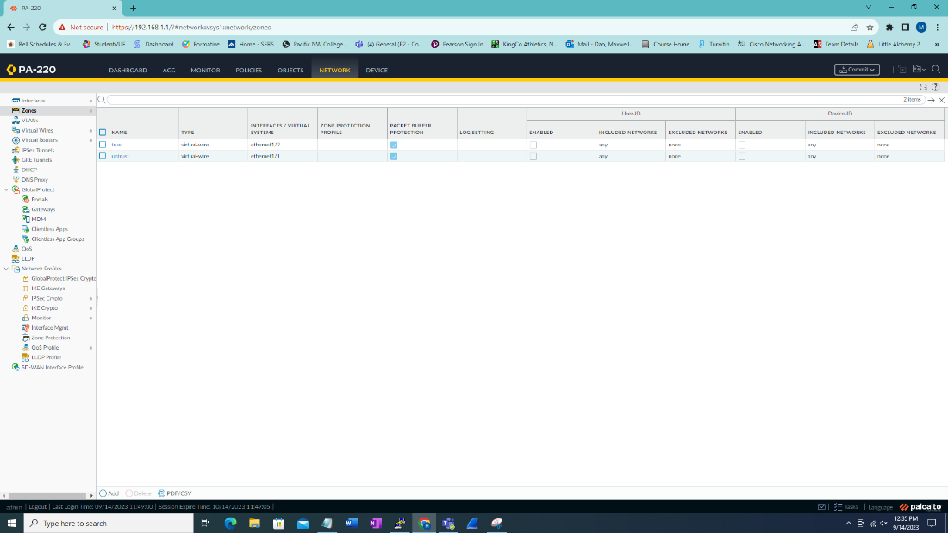

Once in the gui go to network and look at the zones.

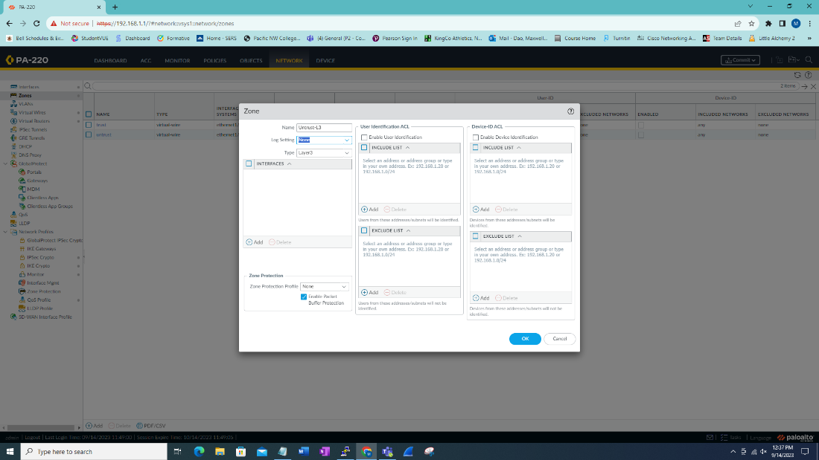

Create new zone named Untrust-L3 with no log settings and a type of Layer3. Repeat for Trust-L3. Repeat for Trust-L2 but with type of layer 2.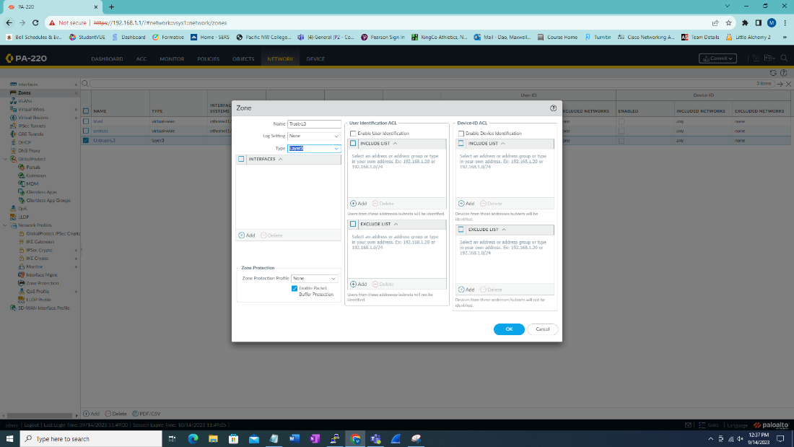

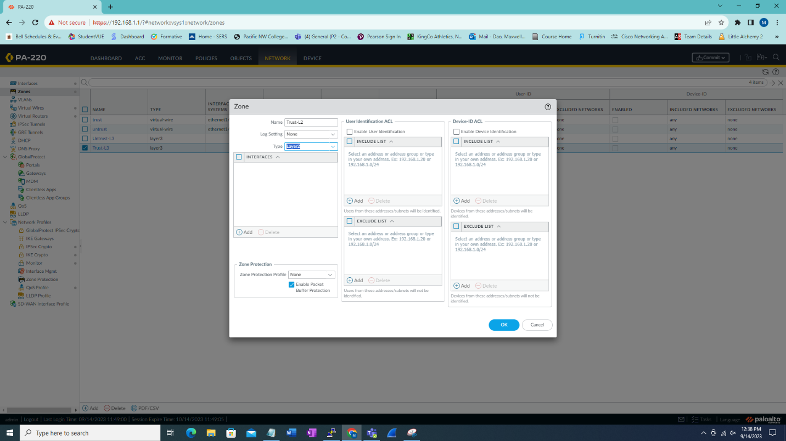

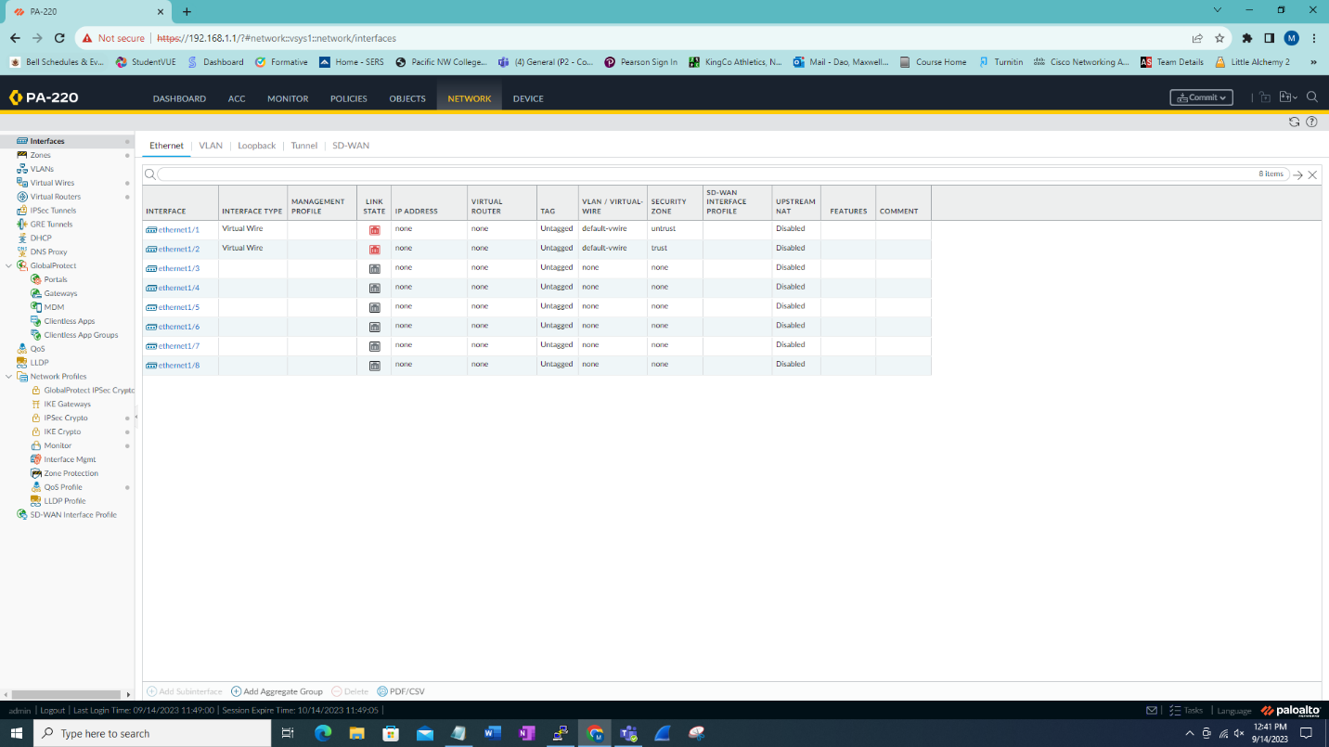

Still under network go under interfaces and edit Ethernet1/1.

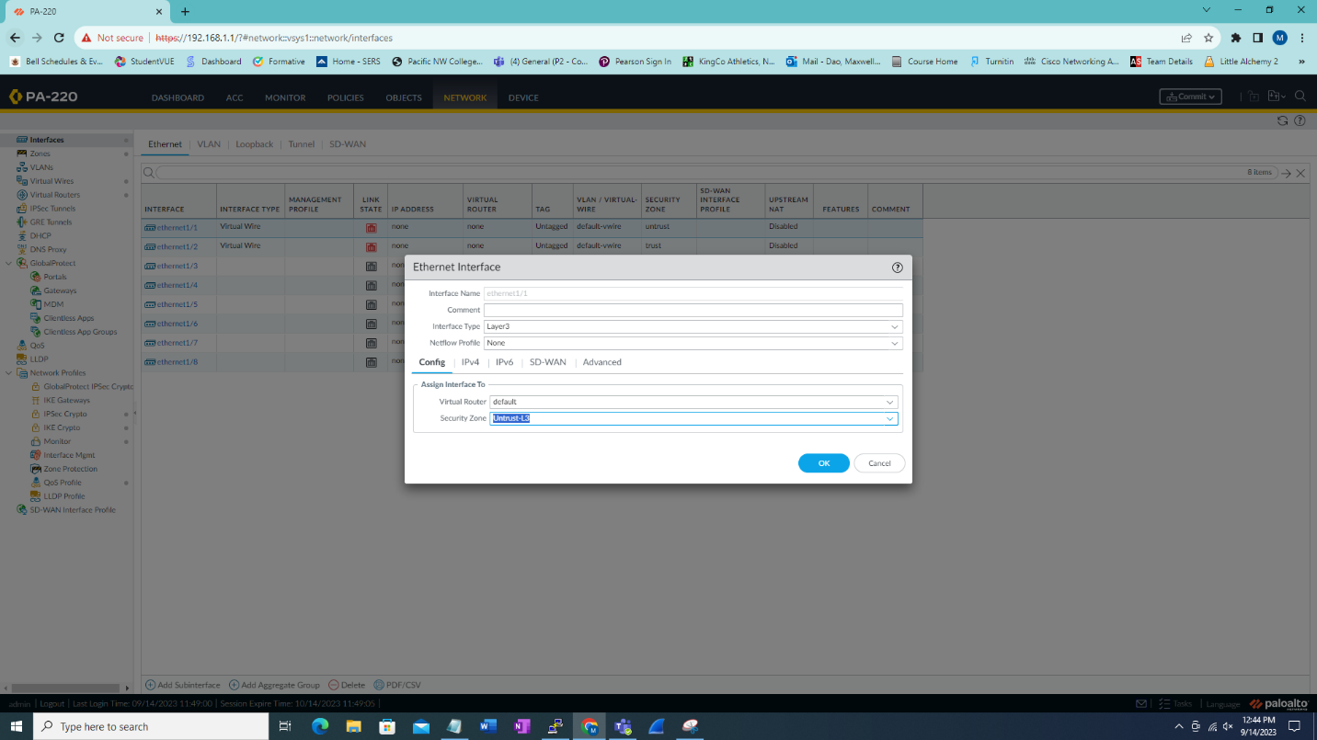

Set the interface type to layer3 with default virtual router and security zone of untrust-L3.

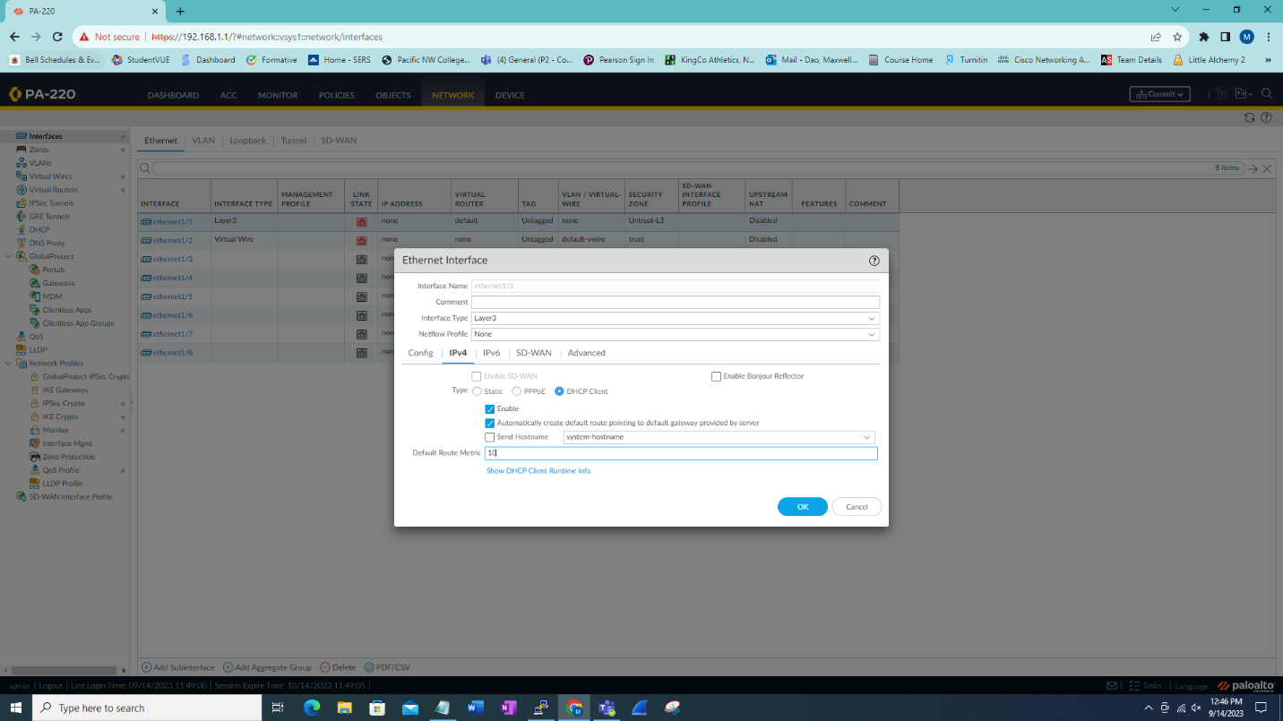

Under ipv4 in the same interface set to DHCP client with the default route metric.

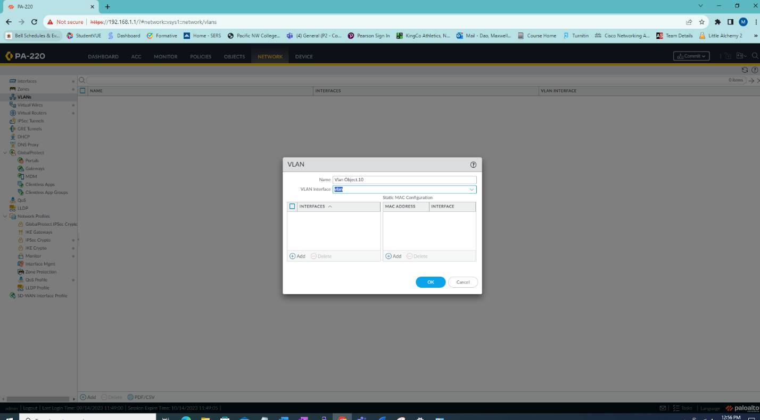

Go under network and select VLANs. Create a new vlan named Vlan Object.10.

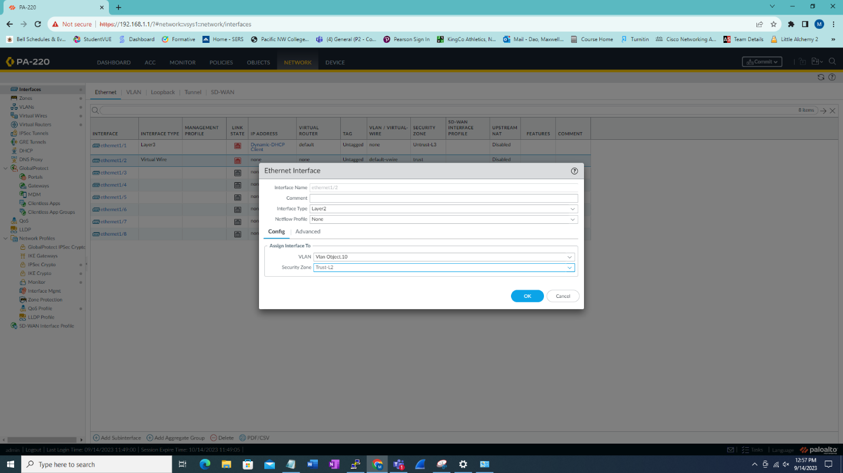

Under interfaces for ethernet 1/2-4, set interface type to layer 2 with the vlan of Vlan Object.10 and security zone of Trust-L2.

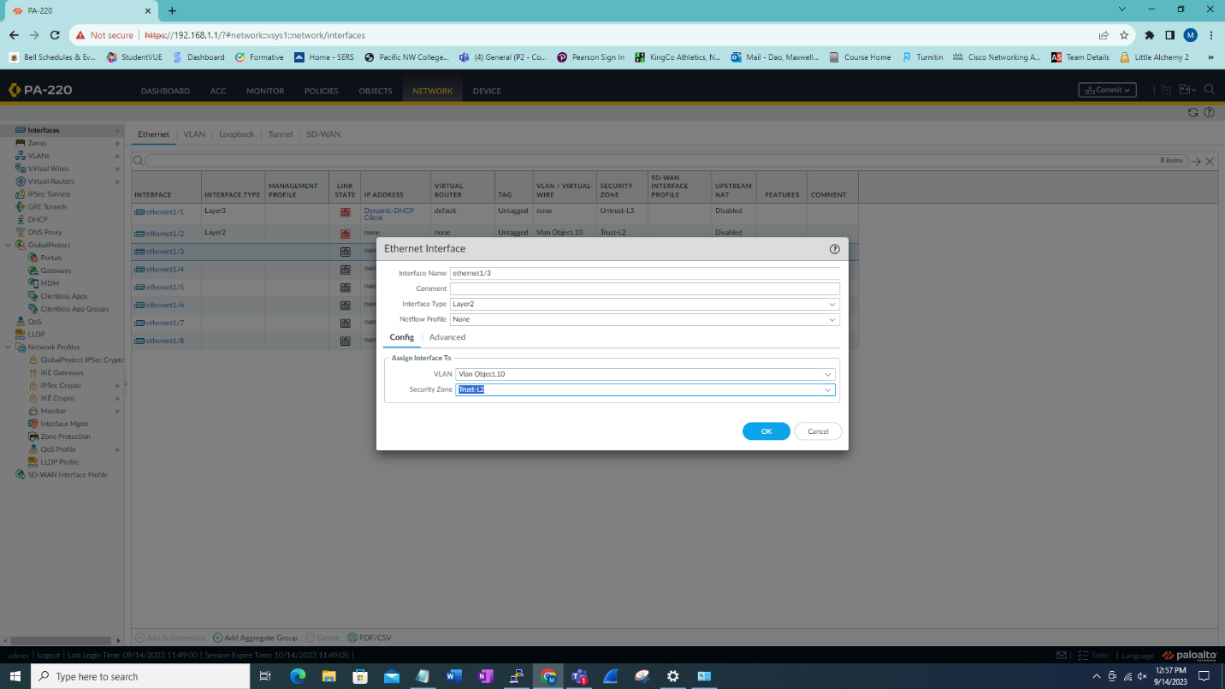

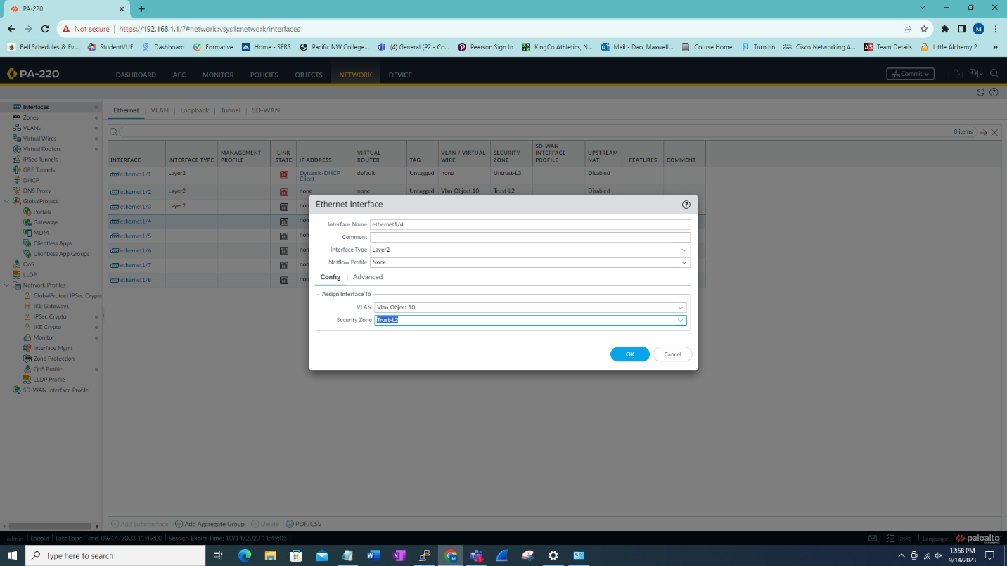

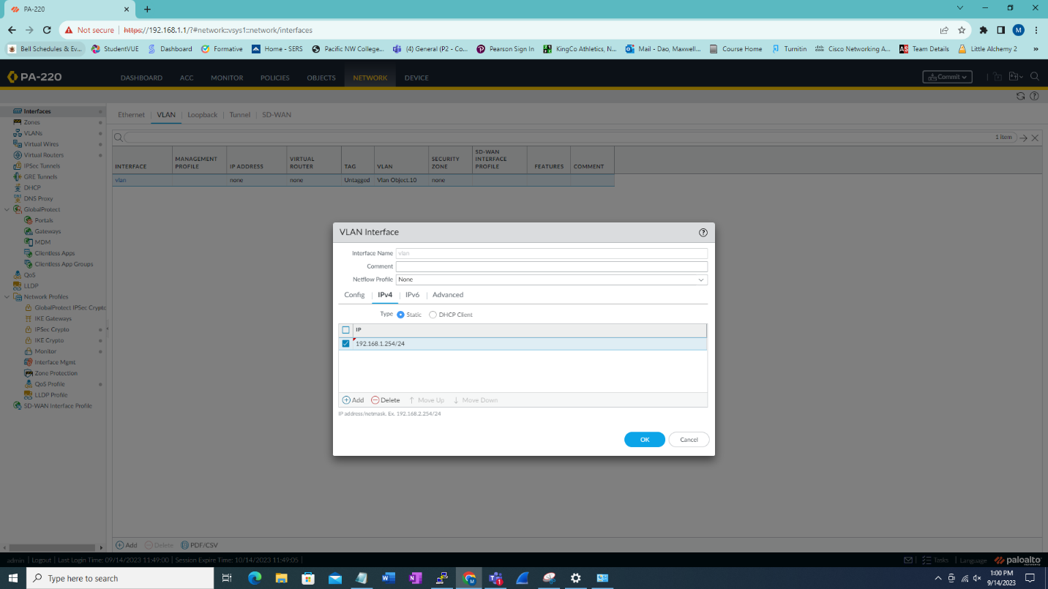

In interfaces edit the vlan with the given ipv4 address.

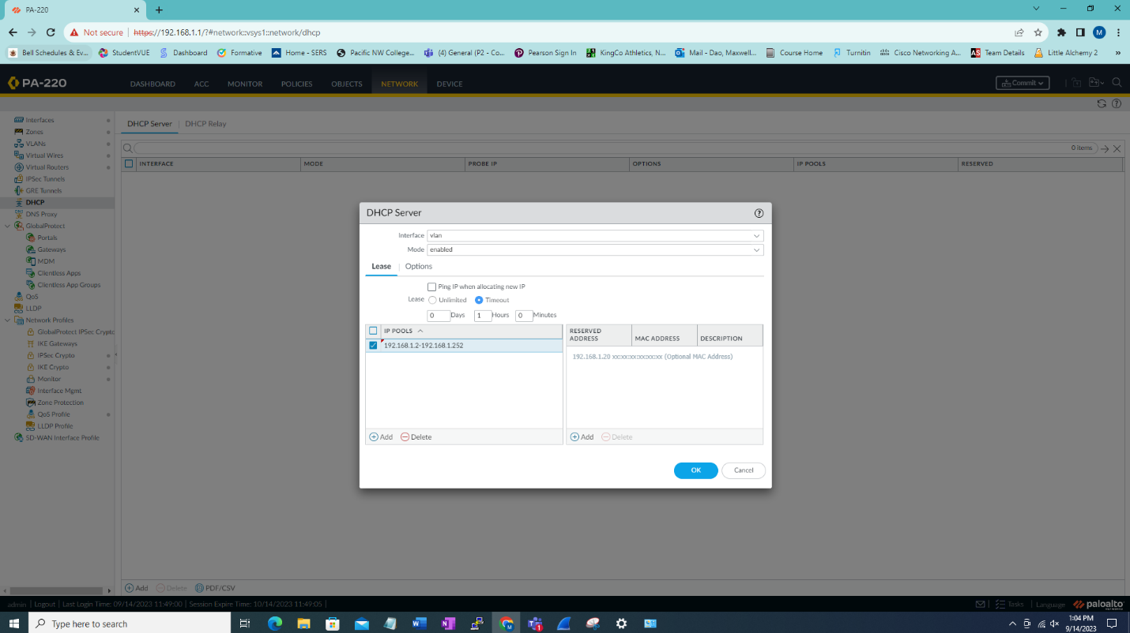

Setup the dhcp pool under network with the given range.

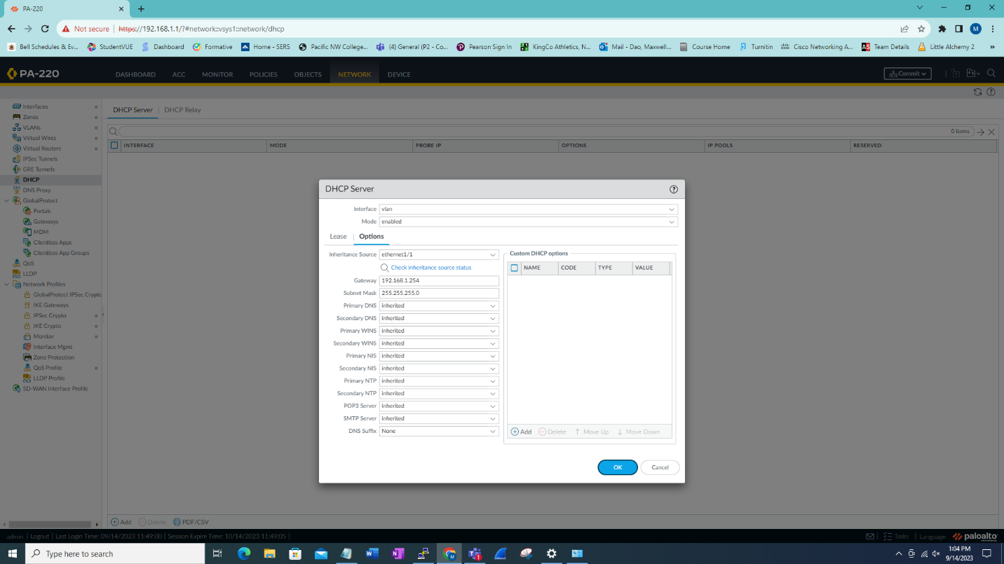

Under options for DHCP set the gateway to the IP of the vlan and set all settings to inherited except DNS Suffix.

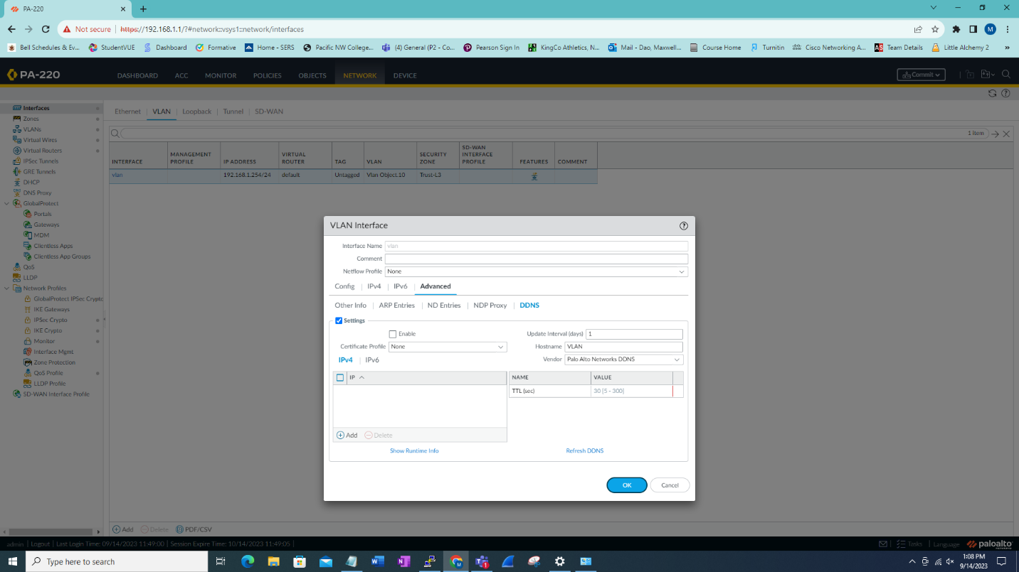

Go back into the vlan interface and set DDNS to allow changing the vlan address with the vendor Palo Alto Networks DDNS.

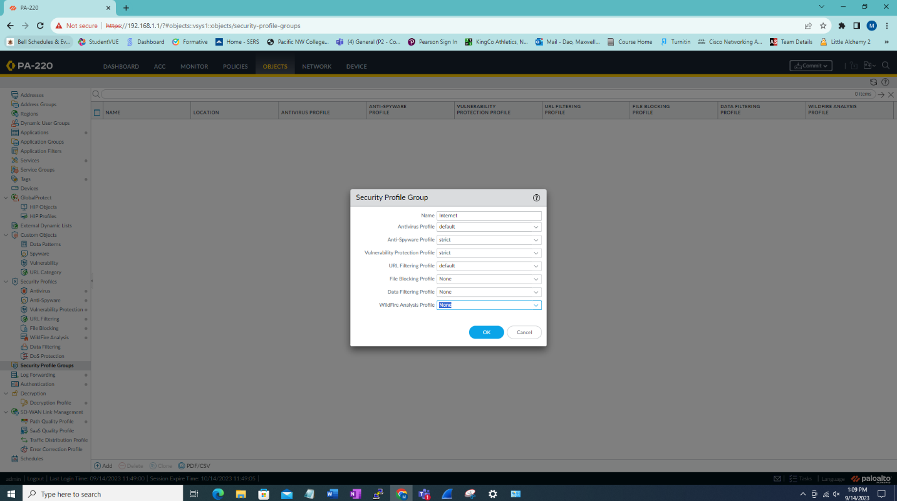

Under objects selects security profile groups use the following settings.

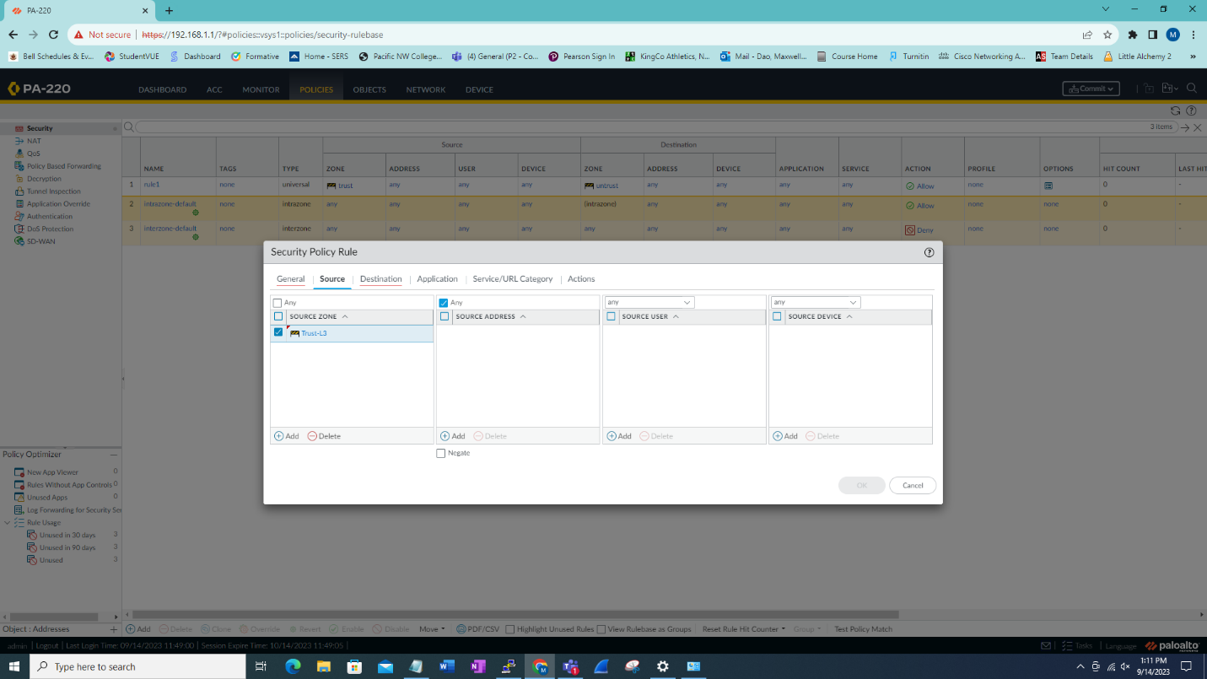

Under policies, go to security and create new policy named Internet Outgoing. Set the source to Trust-L3.

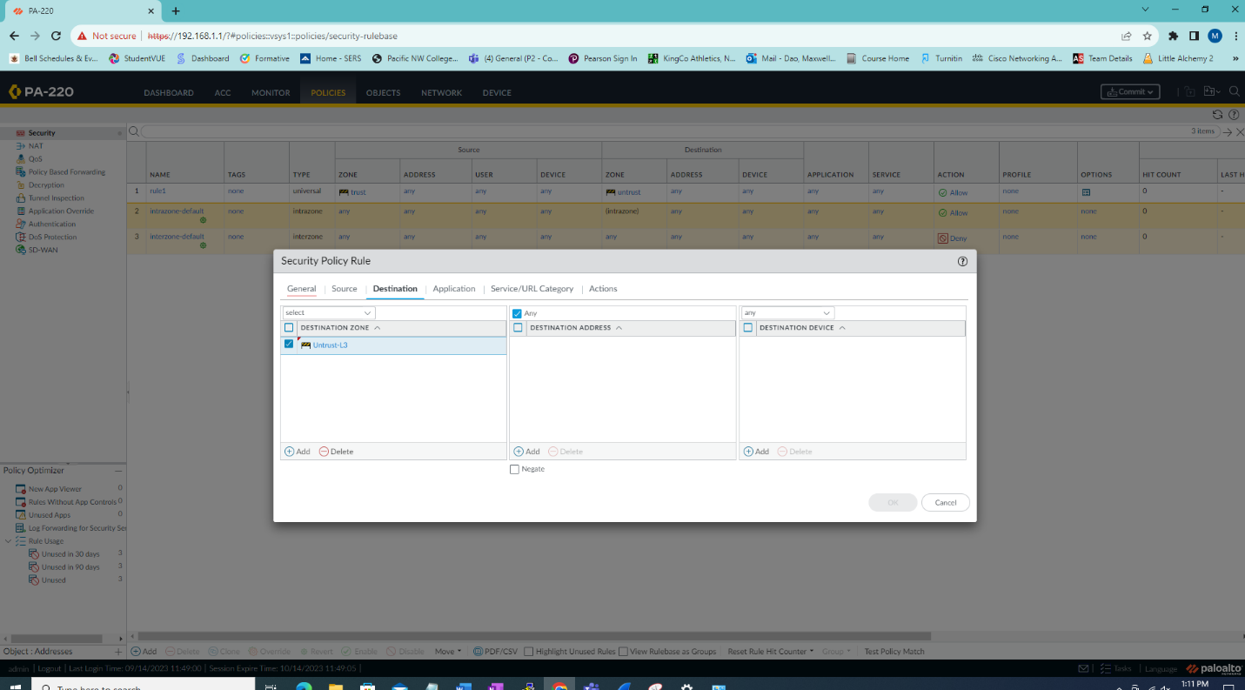

Set the destination to Untrust-L3.

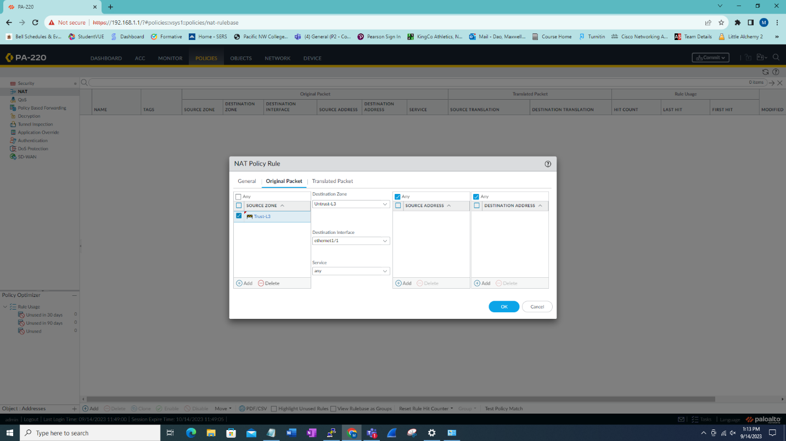

Go to the policy tab under NAT and add new policy named internet outgoing then go to Original Packet then add source zone Trust-L3 and destination zone to Untrust-L3 and destination interface to ethernet1/1 and service any.

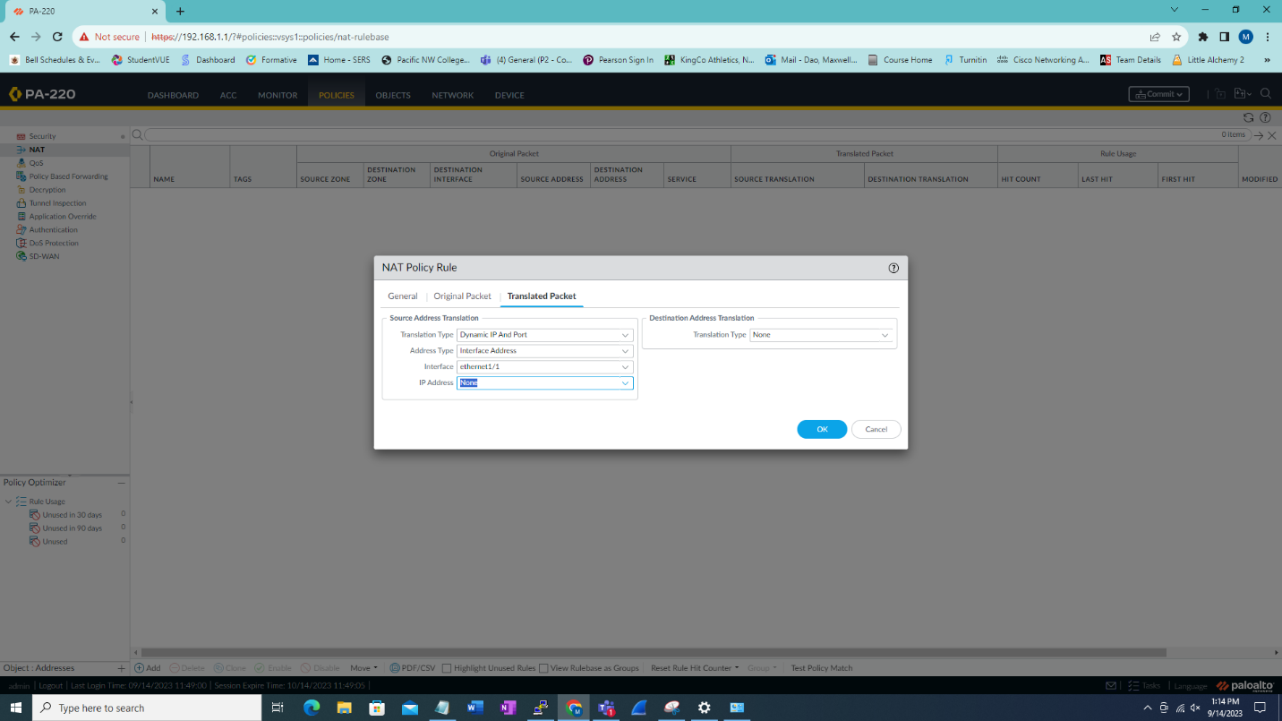

Then go into Translated Packet and then set as shown.

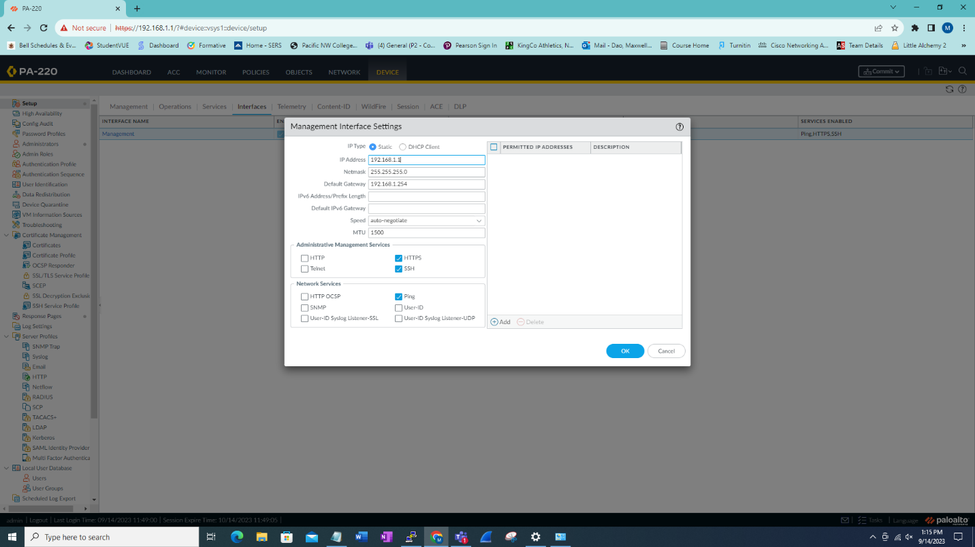

Now go to device then setup into interface then edit management interface to following settings.

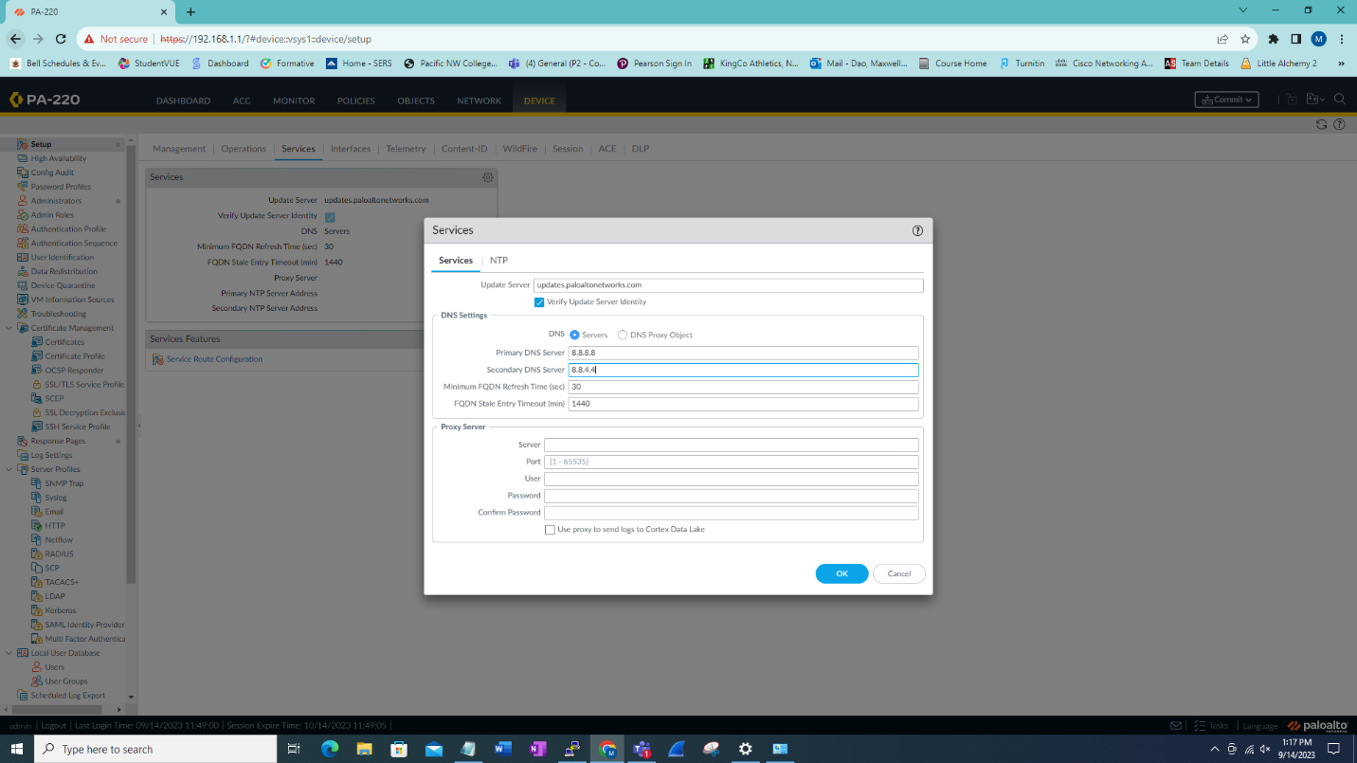

Still in setup go to services then set the DNS to a server (i.e google).

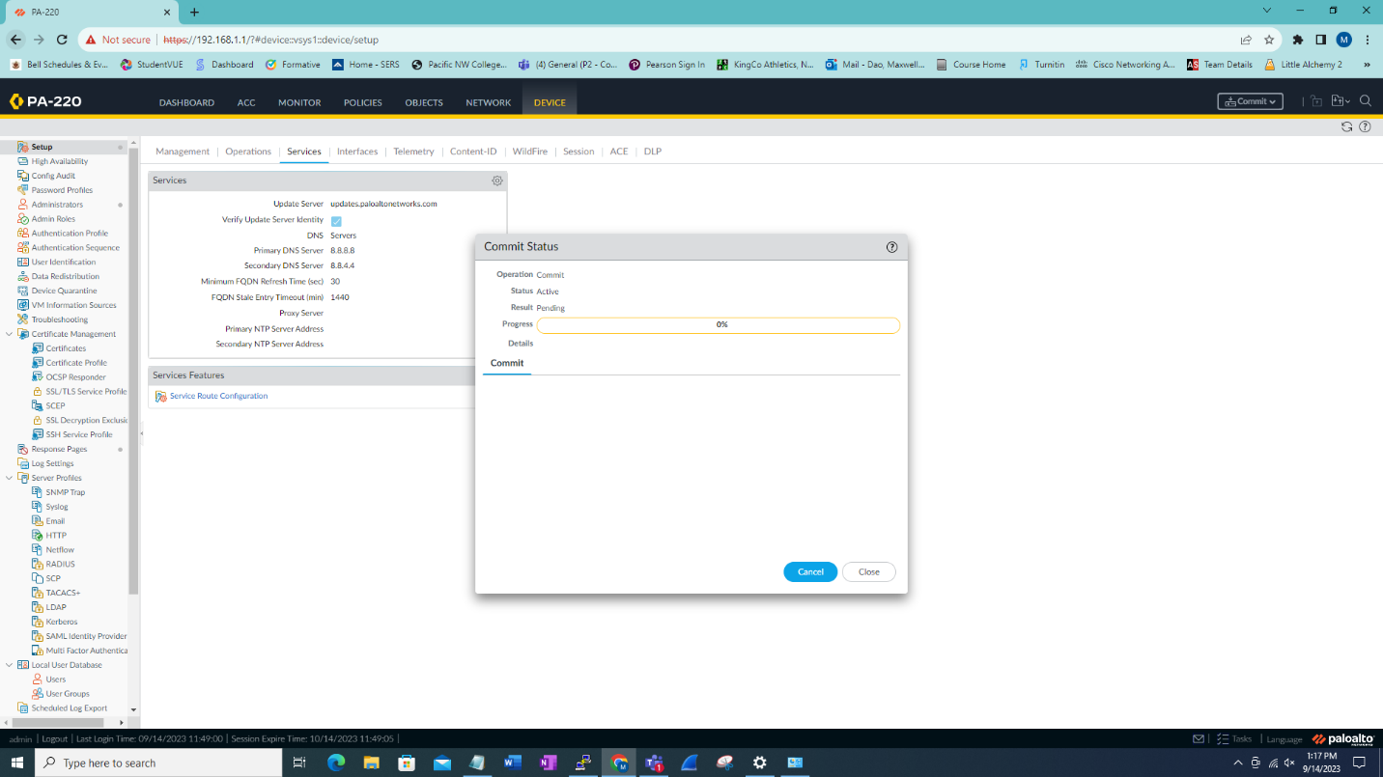

Commit changes.

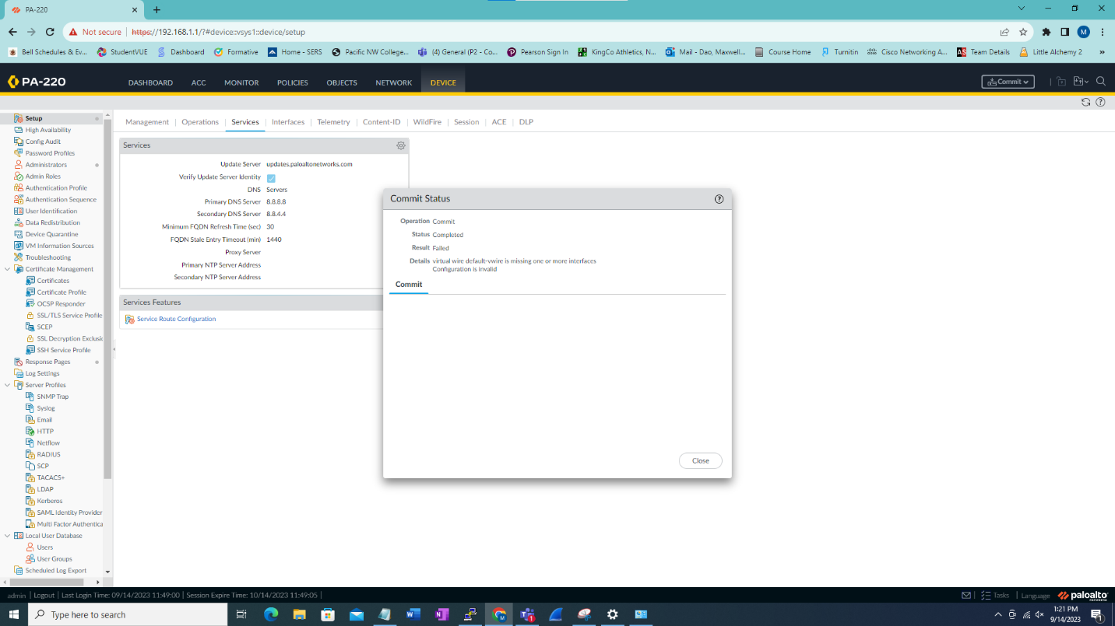

This will fail since we haven’t deleted unnecessary configs.

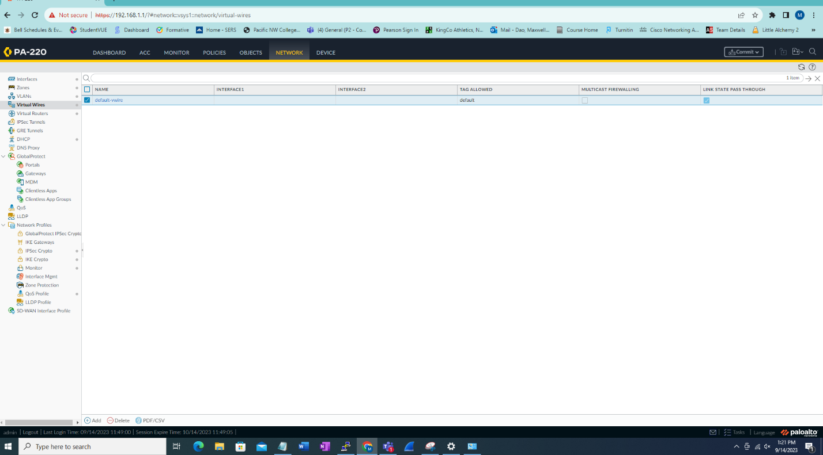

Go into network then Virtual wires then delete the default-vwire.

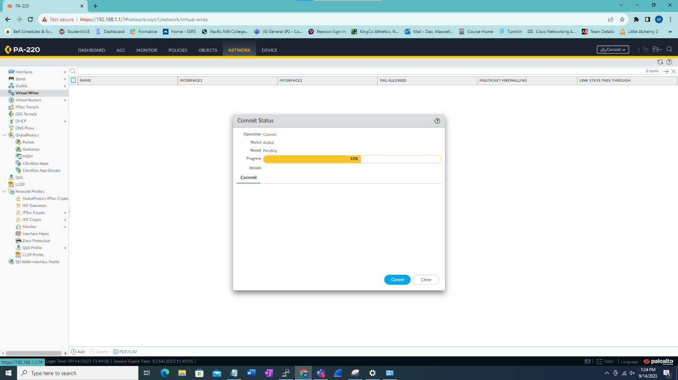

Commit once again.

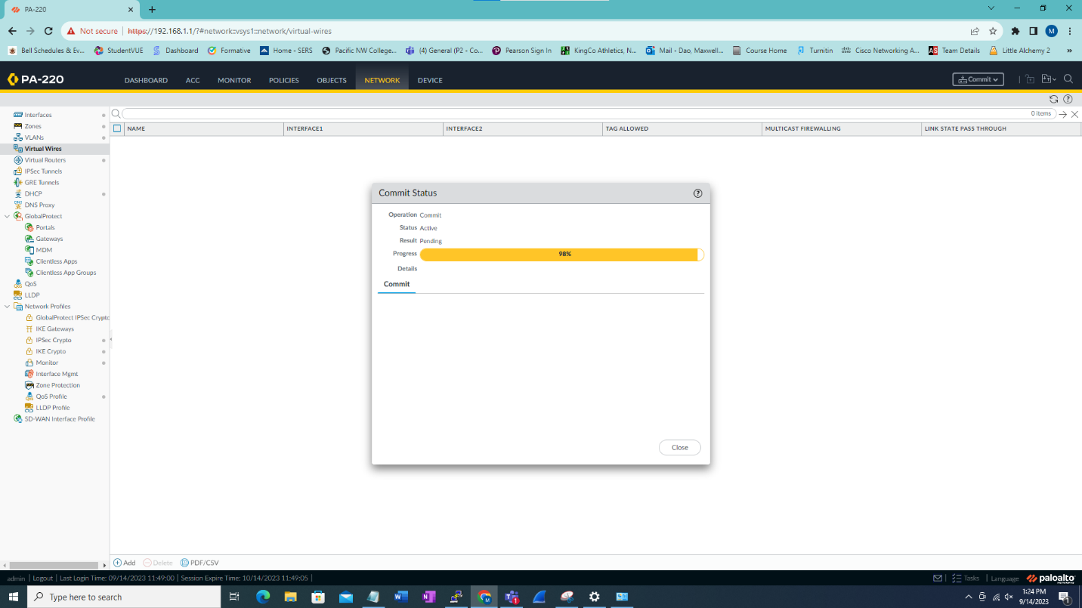

Commit changes.

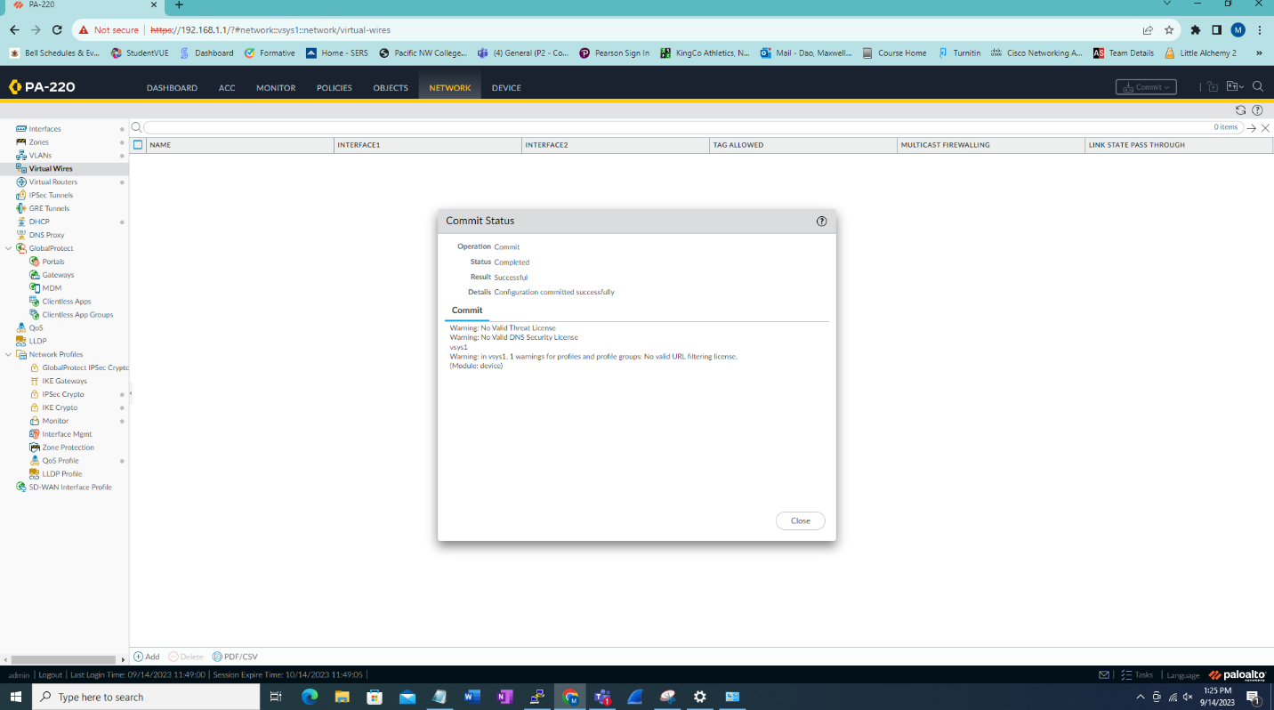

This will show when the commit is successful.

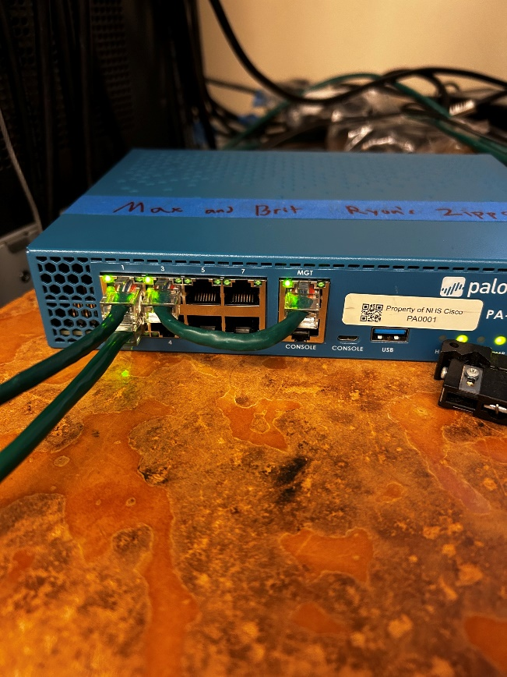

After committing the setting setup cables as shown.

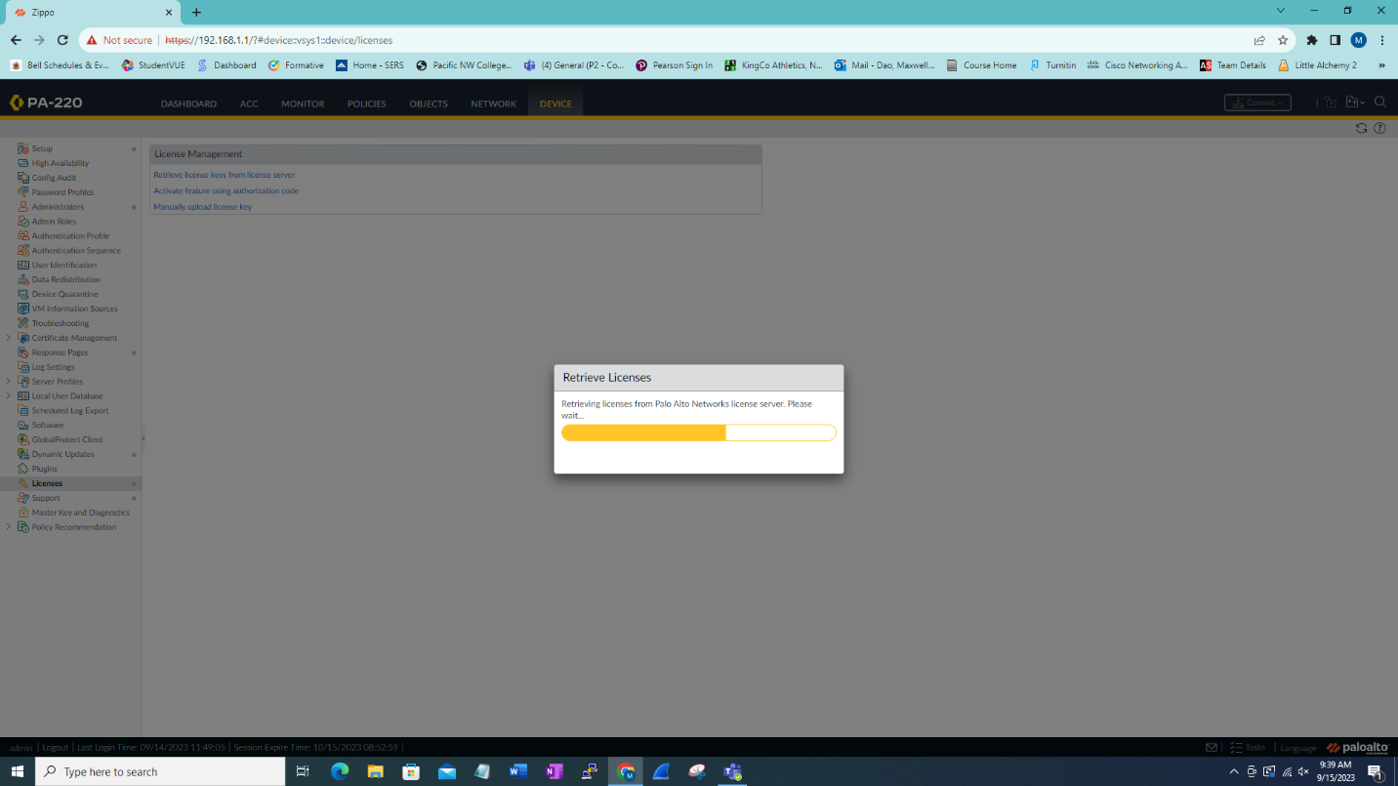

After go into device then Licenses and Retrieve license keys from license server.

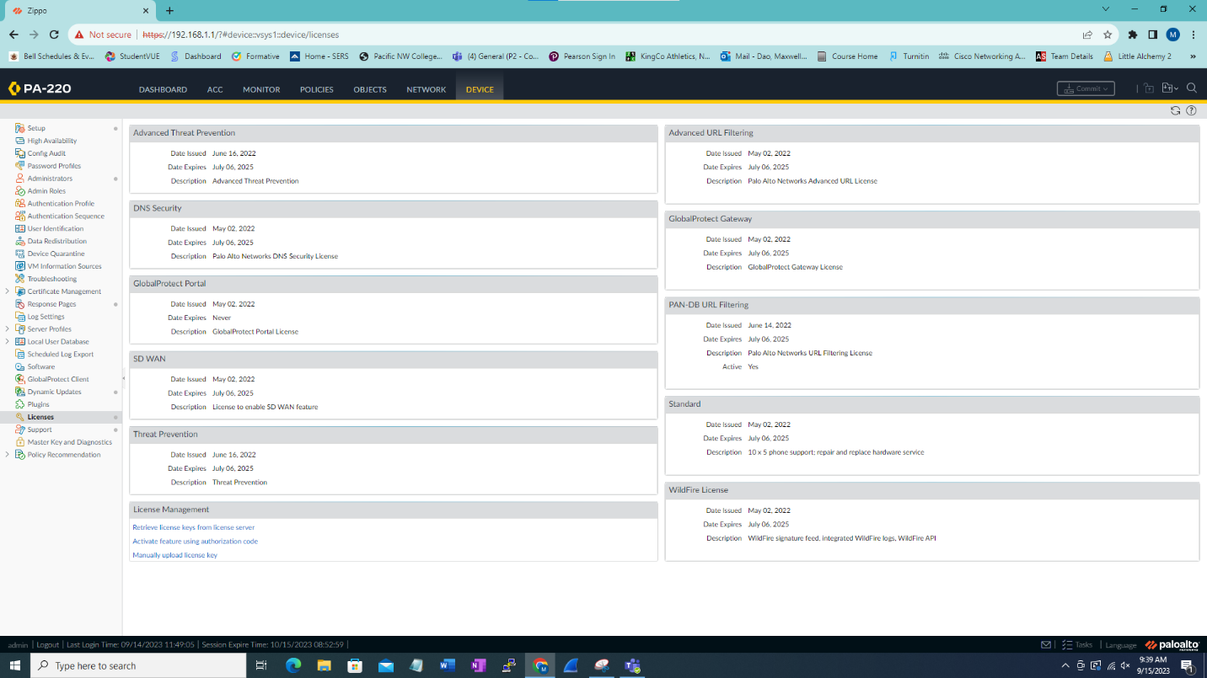

This will show after license have been retrieved.

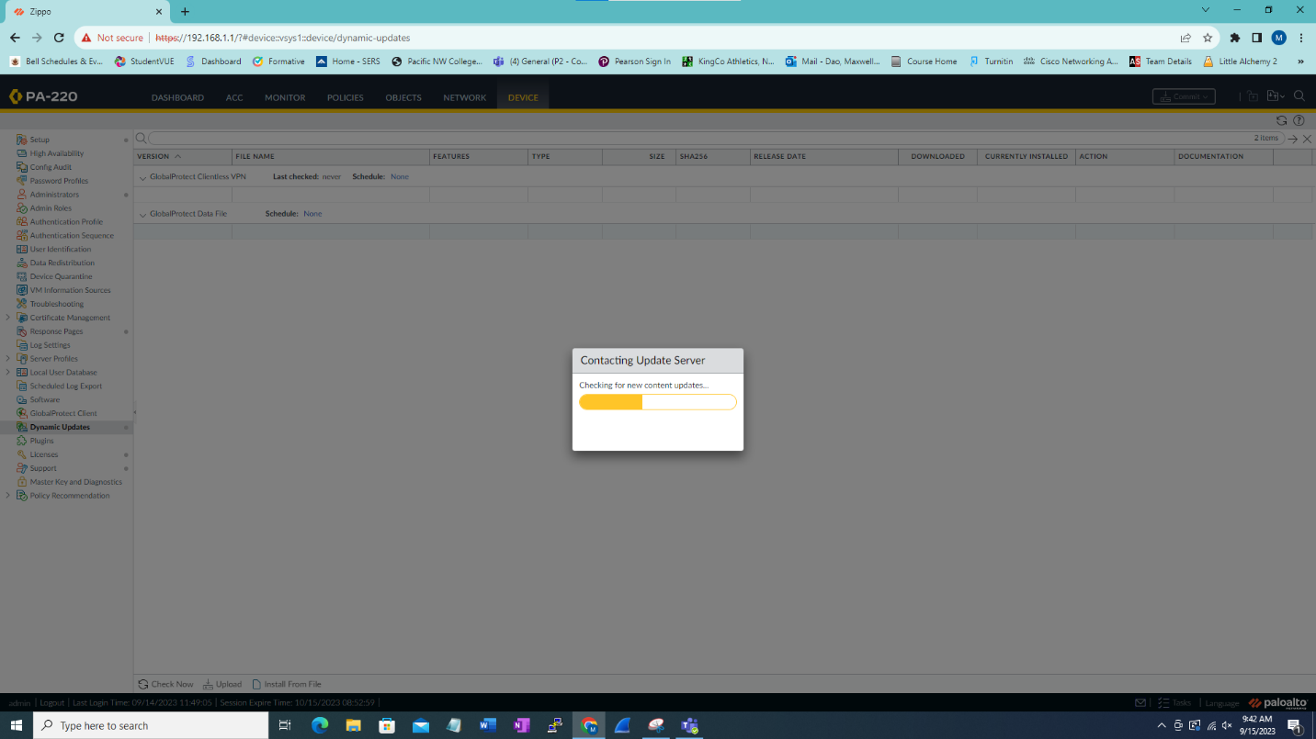

After going into dynamic updates and then click check now.

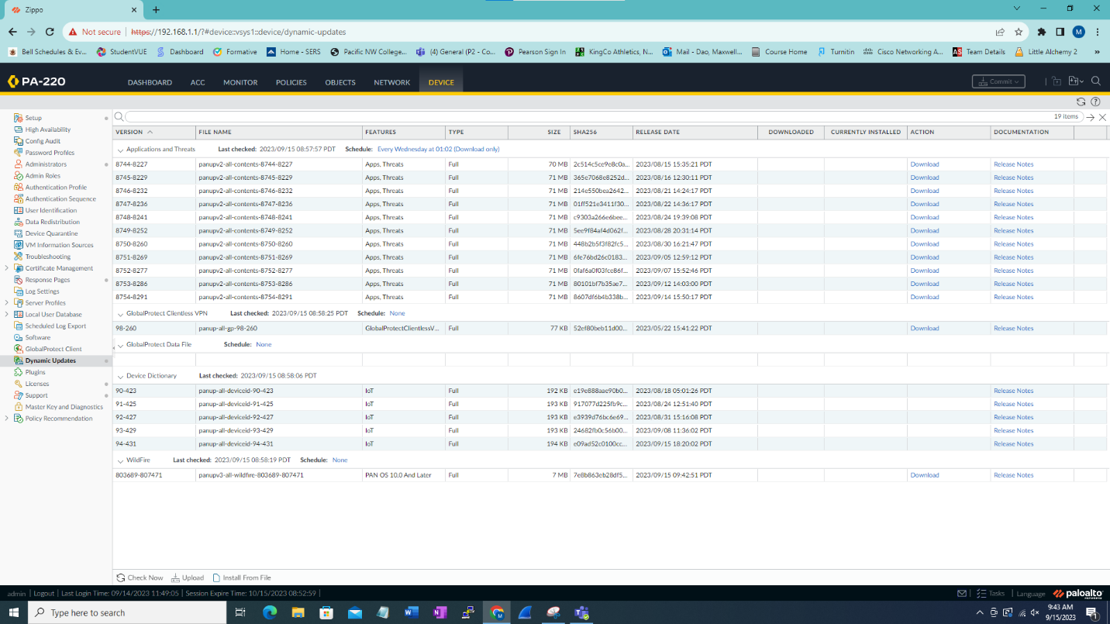

This is the dynamic updates that we have

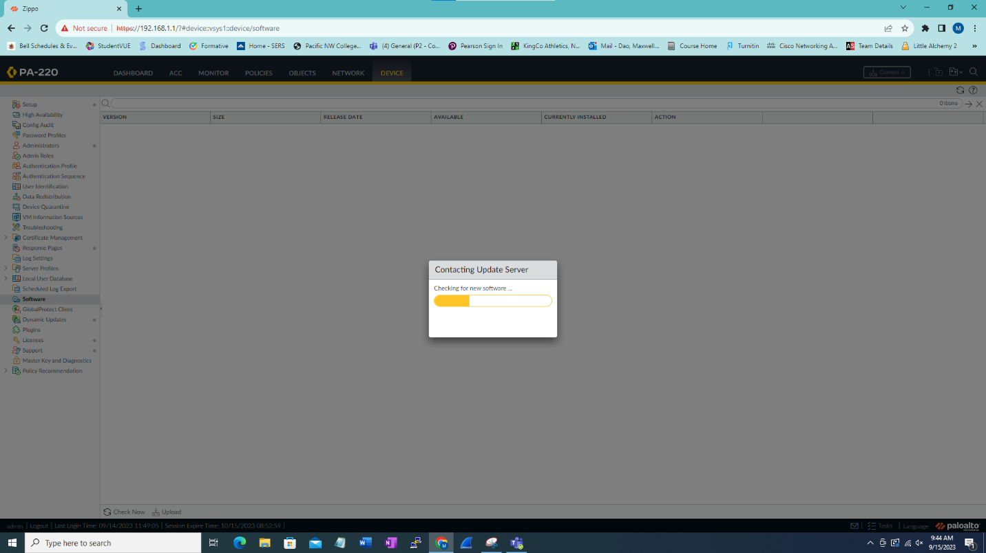

Then go into software updates and then check now.

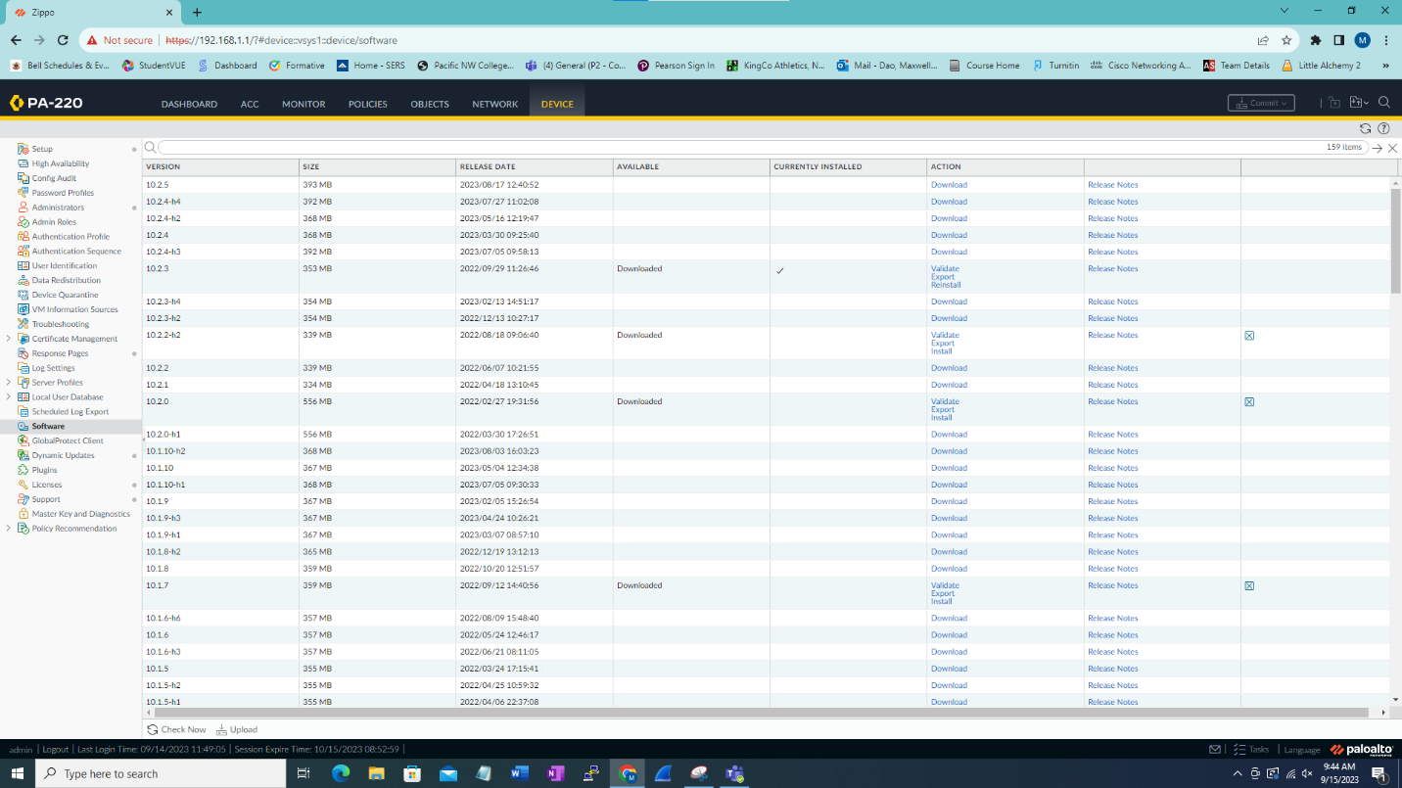

To get the latest update check the newest version which ours was 10.2.3 and then update by going to the highest version of 10.2.x.

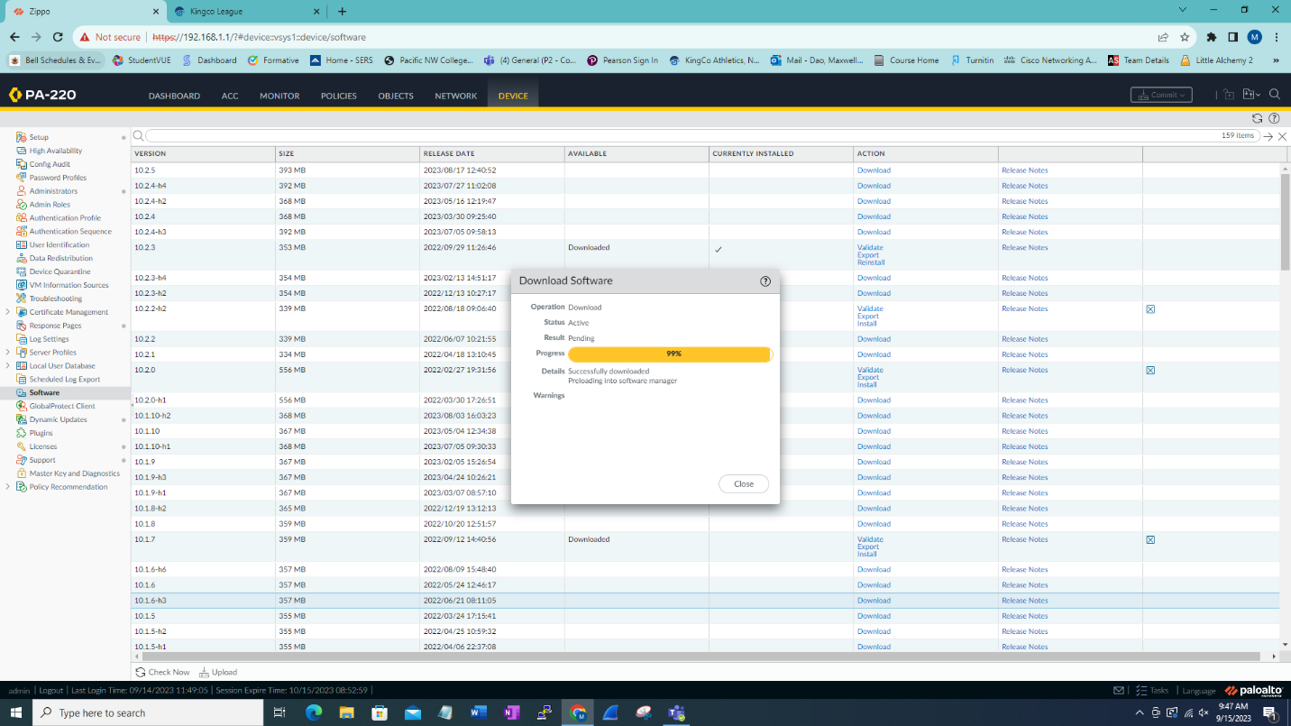

Click download on to highest available download.

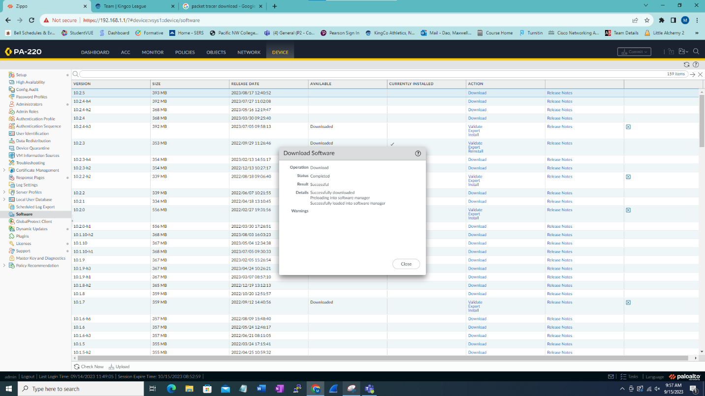

We are now fully updated.

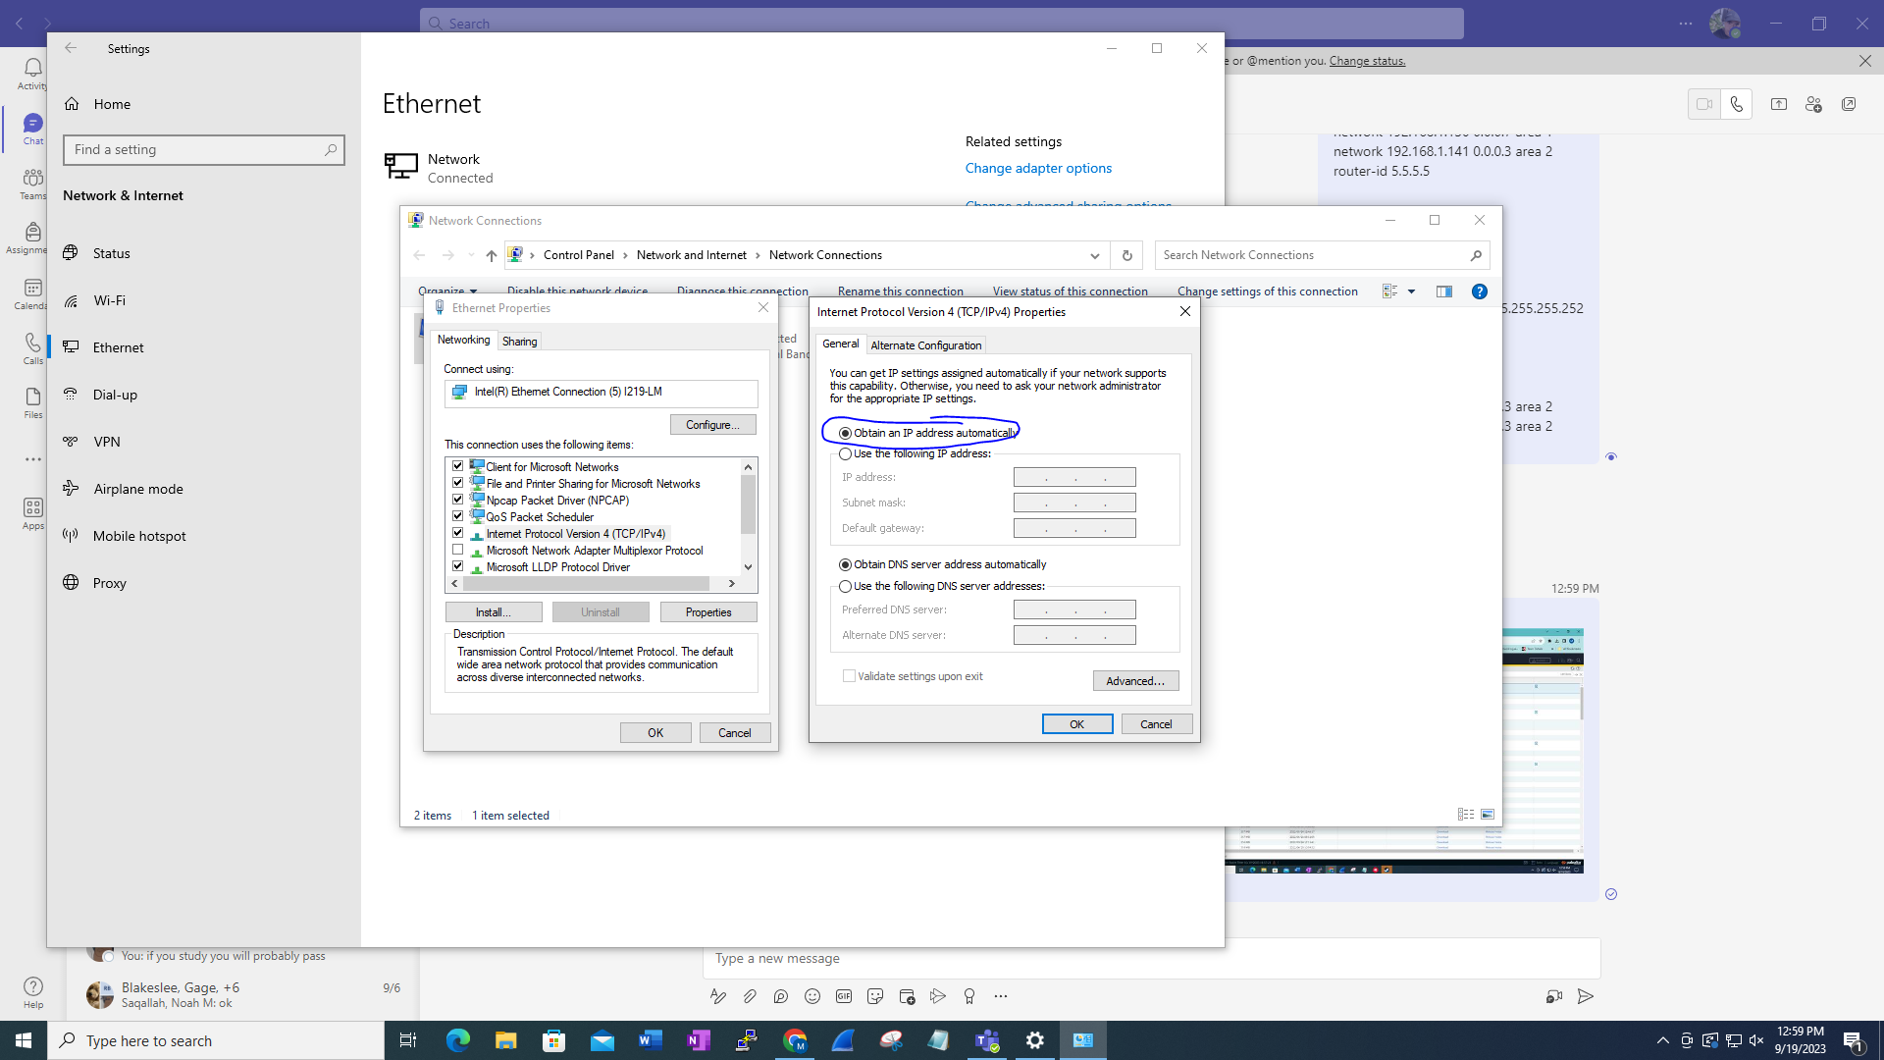

Set both to obtain automatically to make use of the DHCP pool and to able to access the internet. Afterwards you should be able to access websites.

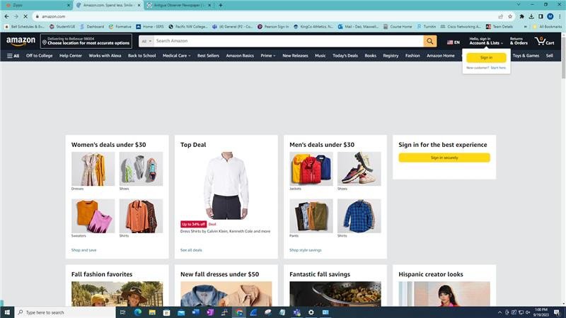



We can also access websites from other coutries.

